**JQuery Fundamentals**

# jQuery Fundamentals

## Course Introduction

## Introduction to jQuery

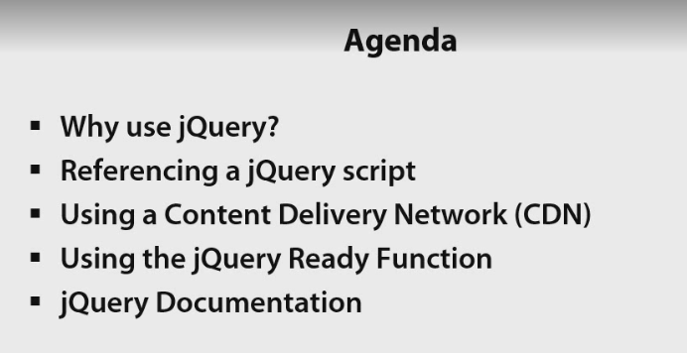

## Why use jQuery?

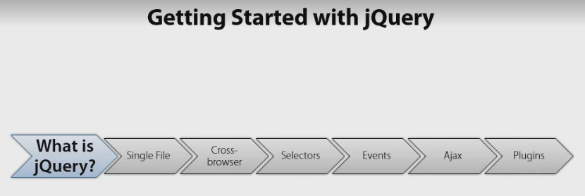

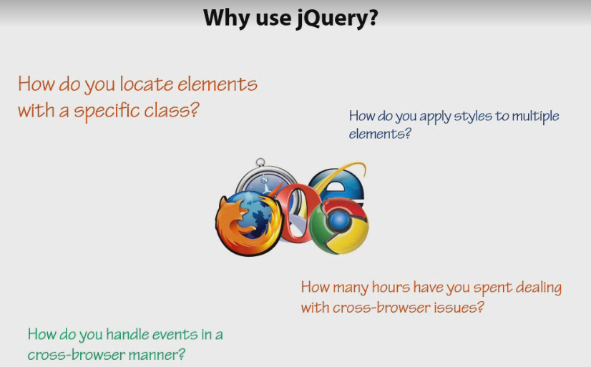

## Getting Started with jQuery

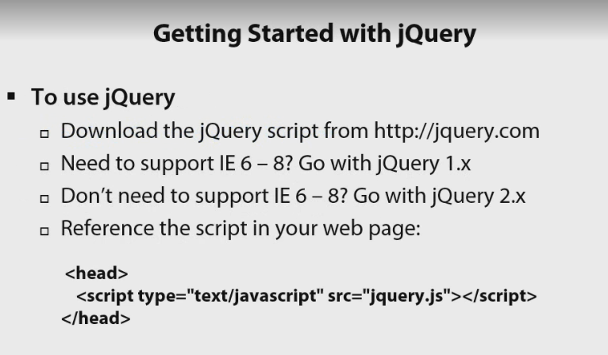

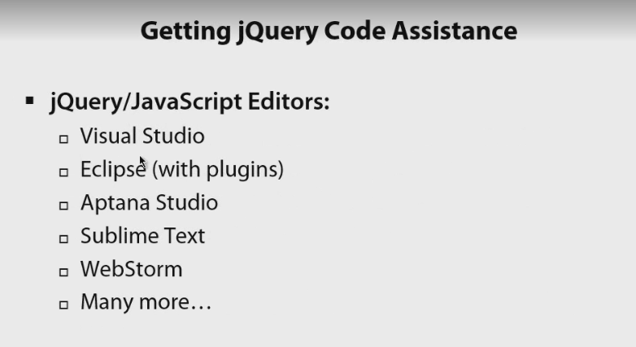

## Using Content Delivery Networks

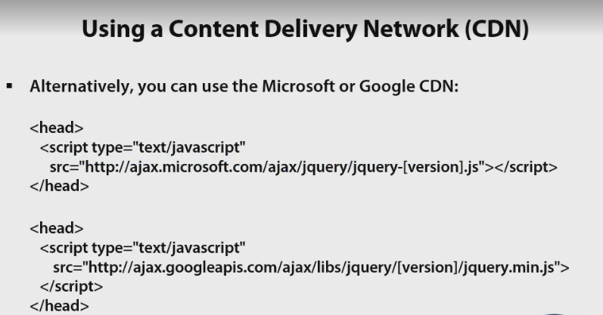

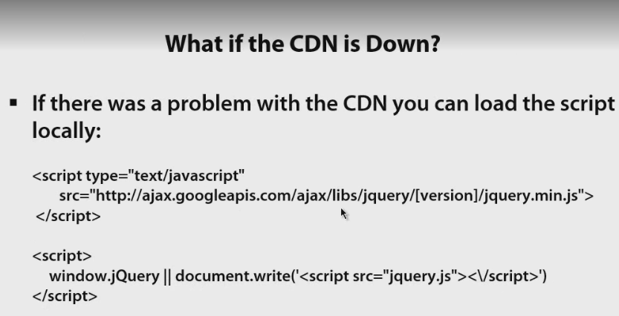

## Using the jQuery ready() Function

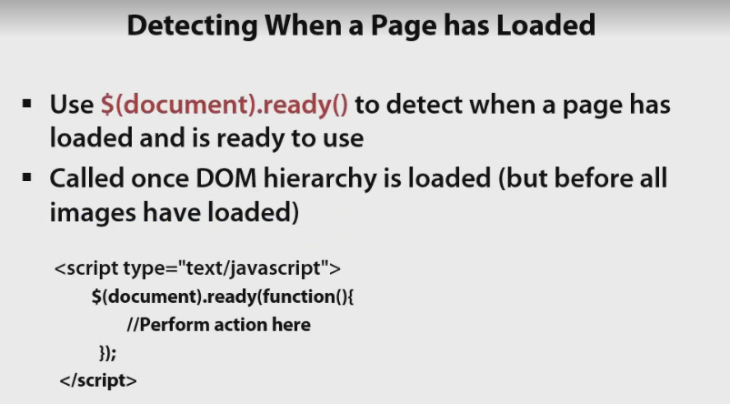

## Getting to Know the jQuery Documentation

## Summary

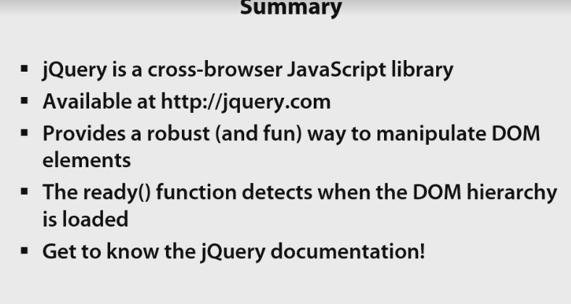

# Using jQuery Selectors

## What are Selectors?

## Selecting Nodes by Tag Name

## Demo

## Selecting Nodes by ID

## ID Selector Demo

## Selecting Nodes by Class Name

## Class Name Selector Demo

## Selecting Nodes by Attribute Value

## Attribute Selector Demo

## Selecting Input Nodes

## Input Selector Demo

## Additional Selector Features

## Additional Selector Features Demo

## Summary

# Interacting with the DOM

## Introduction

## Iterating Through Nodes

## Iterating Through Nodes Demo

## Modifying Properties and Attributes

## Modifying Properties and Attributes Demo

## Adding and Removing Nodes

## Adding and Removing Nodes Demo

## Modifying Styles

## Modifying Styles Demo

## Modifying Classes

## Modifying Classes Demo

## Summary

# Handling Events

## Introduction

## jQuery Event Model Benefits

## Using JavaScript to Handle Events Demo

## Handling Events

## Click Event Demo

## Change Event Demo

## Mouse Events Demo

## Binding to Events

## Binding to Events Demo

## live(), delegate() and on()

## Using on() Demo

## Handling Hover Events

## Hover Events Demo

## Summary

# Working with Ajax Features

## Introduction

## jQuery Ajax Functions

## Loading HTML Content from the Server

## load() Function Demo

## Making GET Requests

## get() Function Demo

## Making POST Requests

## post() Function Demo

## Introduction to the ajax() Function

## ajax() Function Demo

## Summary